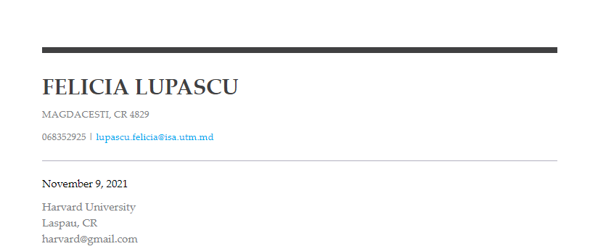

Dear Sir Carter,

I'm writing to convey my desire to attend Harvard University as a student. My schooling, zeal, and professional experience have convinced me that I am uniquely prepared to make an instant difference at Harvard. I am certain that the numerous traineeships and workshops I will take part in during my studies will help me to gain the necessary knowledge and skills*. I have a lot to contribute, as well as a lot to learn from Harvard. Aside from my excitement and commitment, I also have an engineering background from Moldova's Technical University.*

*I've built demonstrated language, persuasive, and communication abilities while working on academic and extracurricular initiatives, which I intend to use to the Student at Harvard role.*

A Bachelor of Engineering from Harvard University will aid in my growth as a team member. The program will assist me in developing strong international relationships and allowing me to meet a large number of well-known and powerful individuals. In addition, the option of performing an internship throughout my education appeals to me. This fantastic opportunity will provide me with the required professional experience to create a successful career in today's competitive environment.

During an interview, I'd be pleased to go over my qualifications and experience in further depth. Please contact me as soon as possible.

Thank you for taking the time to review my request. I eagerly await your excellent reaction.

Yours faithfully,  
Felicia Lupascu